Abstract –
This paper describes the design, structure, functioning and applications of the STM32w108 microcontroller. This is a low-IF, super-heterodyne 32-bit microcontroller. The STM32w108 executes powerful instructions in a single clock cycle, achieving. It has ARM cortex M-3 Microprocessor whose clock speed is configurable to 6 MHz, 12 MHz, or 24 MHz This allows the system designer to optimize power consumption versus processing speed. This paper will draw out the architecture and pin configurations of the microcontroller, describe the basic functions of interrupts, input/output, memories, list out the current usage of the microcontroller in real-life applications and also include brief code examples to show the use of various parts of this device.

Keywords—
- Introduction
The STM32W108 is a fully integrated System-on-Chip that integrates a 2.4 GHz, IEEE 802.15.4-compliant transceiver, 32-bit ARM® Cortex™-M3 microprocessor, Flash and RAM memory, and peripherals of use to designers of 802.15.4-based systems.
The transceiver utilizes an efficient architecture that exceeds the dynamic range requirements imposed by the IEEE 802.15.4-2003 standard by over 15 dB. The integrated receive channel filtering allows for robust co-existence with other communication standards in the 2.4 GHz spectrum, such as IEEE 802.11 and Bluetooth. The integrated regulator, VCO, loop filter, and power amplifier keep the external component count low. An optional high performance radio mode (boost mode) is software-selectable to boost dynamic range.
The integrated 32-bit ARM® Cortex™-M3 microprocessor is highly optimized for high performance, low power consumption, and efficient memory utilization. Including an integrated MPU, it supports two different modes of operation: Privileged mode and Unprivileged mode. This architecture could be used to separate the networking stack from the application code and prevent unwanted modification of restricted areas of memory and registers resulting in increased stability and reliability of deployed solutions.
The STM32W108 has 64 Kbytes of embedded Flash memory and 8 Kbytes of integrated RAM for data and program storage. . The STM32W108 HAL software employs an effective wear-leveling algorithm that optimizes the lifetime of the embedded Flash.
To maintain the strict timing requirements imposed by the IEEE 802.15.4-2003 standards, the STM32W108 integrates a number of MAC functions into the hardware. The MAC hardware handles automatic ACK transmission and reception, automatic backoff delay, and clear channel assessment for transmission, as well as automatic filtering of received packets. A packet trace interface is also integrated with the MAC, allowing complete, non- intrusive capture of all packets to and from the STM32W108.

Features:
• Complete system-on-chip
- 32-bit ARM® Cortex™-M3 processor
- 2.4 GHz IEEE 802.15.4 transceiver & lower MAC
- 8-Kbyte RAM and 64-Kbyte Flash memory
- AES128 encryption accelerator
- –Flexible ADC, SPI/UART/I2C serial communications, and general-purpose timers
- 24 highly configurable GPIOs with Schmitt trigger inputs

• Industry-leading ARM® Cortex™-M3 processor
- Leading 32-bit processing performance
- Highly efficient Thumb®-2 instruction set
- Operation at 6, 12 or 24 MHz
- Flexible nested vectored interrupt controller

• Low power consumption, advanced management
- Receive current (w/ CPU): 27 mA
- Transmit current (w/ CPU, +3 dBm TX): 31 mA
- Low deep sleep current, with retained RAM and GPIO: 400 nA/800 nA with/without sleep timer
- Low-frequency internal RC oscillator for low-power sleep timing
- High-frequency internal RC oscillator for fast (100 µs) processor start-up from sleep

• Exceptional RF performance
- Normal mode link budget up to 102 dB; configurable up to 107 dB
- -99 dBm normal RX sensitivity; configurable to -100 dBm (1% PER, 20 byte packet)
- +3 dB normal mode output power;
- configurable up to +8 dBm
- Robust WiFi and Bluetooth coexistence

• Innovative network and processor debug
- Non-intrusive hardware packet trace
- Serial wire/JTAG interface
- Standard ARM debug capabilities: Flash patch & breakpoint; data watchpoint & trace; instrumentation trace macrocell

• Application flexibility
- Single voltage operation: 2.1-3.6 V with internal 1.8 V and 1.25 V regulators
- Optional 32.768 kHz crystal for higher timer accuracy
- Low external component count with single 24 MHz crystal
- Support for external power amplifier – Small 7x7 mm 48-pin VFQFPN package

Applications:
- RF4CE products and remote controls
- 6LoWPAN and custom protocols
- 802.15.4 based network protocols (standard and proprietary)

- Architecture

Functional description:

The STM32W108 radio receiver is a low-IF, super-heterodyne receiver. The architecture has been chosen to optimize co-existence with other devices in the 2.4 GHz band (namely, WIFI and Bluetooth), and to minimize power consumption. The receiver uses differential signal paths to reduce sensitivity to noise interference. Following RF amplification, the signal is downconverted by an image-rejecting mixer, filtered, and then digitized by an ADC.

The radio transmitter uses an efficient architecture in which the data stream directly modulates the VCO frequency. An integrated power amplifier (PA) provides the output power. Digital logic controls Tx path and output power calibration. If the STM32W108 is to be used with an external PA, use the TX_ACTIVE or nTX_ACTIVE signal to control the timing of the external switching logic. Other pins given in the table.

ARM® Cortex™-M3 core:

The STM32W108 integrates the ARM® Cortex™-M3 microprocessor, revision r1p1, developed by ARM Ltd, making the STM32W108 a true system-on-a-chip solution. The ARM® Cortex-M3 is an advanced 32-bit modified Harvard architecture processor that has separate internal program and data buses, but presents a unified program and data address space to software. The word width is 32 bits for both the program and data sides. The ARM® Cortex-M3 allows unaligned word and half-word data accesses to support efficiently-packed data structures.

The ARM® Cortex-M3 clock speed is configurable to 6 MHz, 12 MHz, or 24 MHz. For normal operation 12 MHz is preferred over 24 MHz due to its lower power consumption. The 6 MHz operation can only be used when radio operations are not required since the radio requires an accurate 12 MHz clock.

The ARM® Cortex-M3 in the STM32W108 has also been enhanced to support two separate memory protection levels. Basic protection is available without using the MPU, but the usual operation uses the MPU. The MPU protects unimplemented areas of the memory map to prevent common software bugs from interfering with software operation. The architecture could also separate the networking stack from the application code using a fine granularity RAM protection module. Errant writes are captured and details are reported to the developer to assist in tracking down and fixing issues.

The processor incorporates:

• Memory Protection Unit (MPU). An optional MPU for memory protection:
— Eight memory regions.
— Sub Region Disable (SRD), enabling efficient use of memory regions.
— You can enable a background region that implements the default memory
map attributes.
• Bus interfaces:
— Advanced High-performance Bus-Lite (AHB-Lite) ICode, DCode and
System bus interfaces.
— Advanced Peripheral Bus (APB) and Private Peripheral Bus (PPB)
Interface.
— Bit band support that includes atomic bit band write and read operations.
— Memory access alignment.
— Write buffer for buffering of write data.
• Low-cost debug solution that features:
— Debug access to all memory and registers in the system, including
Cortex-M3 register bank when the core is running, halted, or held in reset.
— Serial Wire Debug Port (SW-DP) or Serial Wire JTAG Debug Port
(SWJ-DP) debug access, or both.
— Flash Patch and Breakpoint (FPB) unit for implementing breakpoints and
code patches.
— Data Watchpoint and Trace (DWT) unit for implementing watchpoints,
data tracing, and system profiling.
— Instrumentation Trace Macrocell (ITM) for support of printf style
debugging.
— Trace Port Interface Unit (TPIU) for bridging to a Trace Port Analyzer
(TPA).
— Optional Embedded Trace Macrocell (ETM) for instruction trace.
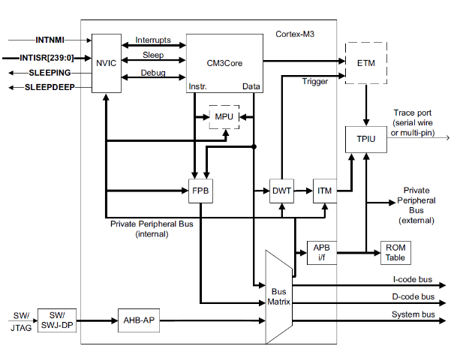

Cortex-M3 block diagram

Components:

• Processor core
• NVIC -The NVIC is tightly coupled to the processor core. This facilitates low latency exception
processing.
• Bus Matrix -The bus matrix connects the processor and debug interface to the external buses.
• FPB - The FPB unit implements hardware breakpoints and patches accesses from code space
to system space.
• DWT -The DWT unit incorporates the debug functionality
• ITM -The ITM is a an application driven trace source that supports application event trace and
printf style debugging.
• MPU -An optional MPU is available for the processor to provide memory protection. The
MPU checks access permissions and memory attributes. It contains eight regions, and
an optional background region that implements the default memory map attributes.
• ETM -The ETM is a low-cost trace macrocell that supports instruction trace only.
• TPIU -The TPIU acts as a bridge between the Cortex-M3 trace data from the ITM, an ETM if
present, and an off-chip Trace Port Analyzer. You can configure the TPIU to support
either serial pin trace for low-cost debug, or multi-pin trace for higher bandwidth trace.

Execution pipeline stages:

The names of the pipeline stages and their functions are:
Fe Instruction fetch where data is returned from the instruction memory.
De Instruction decode, generation of LSU address using forwarded register
ports, and immediate offset or LR register branch forwarding.
Ex Instruction execute, single pipeline with multi-cycle stalls, LSU address/data pipelining to AHB interface, multiply/divide, and ALU with
branch result.
The pipeline structure provides a pipelined 2-cycle memory access with no ALU usage
penalty, address generation forwarding for pointer indirection.

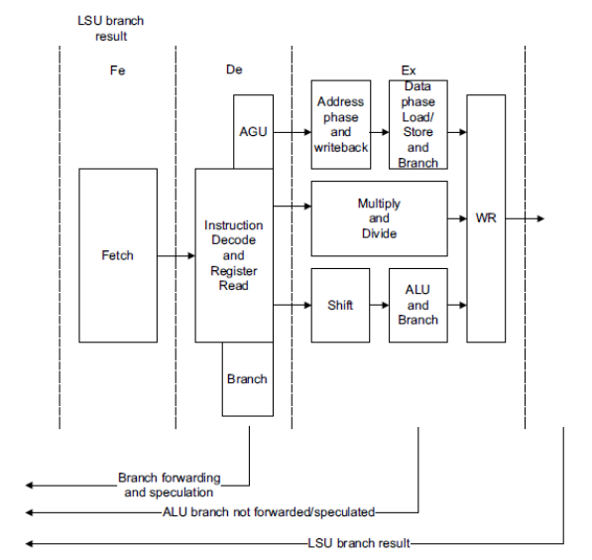

Cortex-M3 Pipeline
Some Instructions:

Add register value, immediate 12-bit value, and C bit -ADC{S}.W <Rd>, <Rn>, #<modify_constant(immed_12>
Add register value, shifted register value, and C bit - ADC{S}.W <Rd>, <Rn>, <Rm>{, <shift>}
Add register value and immediate 12-bit value ADD{S}.W <Rd>, <Rn>, #<modify_constant(immed_12)>
Add register value and shifted register value ADD{S}.W <Rd>, <Rm>{, <shift>}
Add register value and immediate 12-bit value ADDW.W <Rd>, <Rn>, #<immed_12>
Bitwise AND register value with immediate 12-bit value AND{S}.W <Rd>, <Rn>, #<modify_constant(immed_12>
Bitwise AND register value with shifted register value AND{S}.W <Rd>, <Rn>, Rm>{, <shift>}
Arithmetic shift right by number in register ASR{S}.W <Rd>, <Rn>, <Rm>
Conditional branch B{cond}.W <label>
Clear bit field BFC.W <Rd>, #<lsb>, #<width>
Insert bit field from one register value into another BFI.W <Rd>, <Rn>, #<lsb>, #<width>
Bitwise AND register value with complement of immediate
12-bit value
BIC{S}.W <Rd>, <Rn>, #<modify_constant(immed_12)>
Bitwise AND register value with complement of shifted
register value
BIC{S}.W <Rd>, <Rn>, <Rm>{, <shift>}
Branch with link BL <label>
Branch with link (immediate) BL<c> <label>
Unconditional branch B.W <label>
Clear exclusive clears the local record of the executing
processor that an address has had a request for an exclusive
access.
CLREX <c>
Return number of leading zeros in register value CLZ.W <Rd>, <Rn>
Compare register value with two’s complement of immediate
12-bit value
CMN.W <Rn>, #<modify_constant(immed_12)>
Compare register value with two’s complement of shifted
register value
CMN.W <Rn>, <Rm>{, <shift>}
Compare register value with immediate 12-bit value CMP.W <Rn>, #<modify_constant(immed_12)>
Compare register value with shifted register value CMP.W <Rn>, <Rm>{, <shift>}

Registers:

The processor has the following 32-bit registers:
• 13 general-purpose registers, r0-r12
• stack point alias of banked registers, SP_process and SP_main
• link register, r14
• program counter, r15
• one program status register, xPSR.

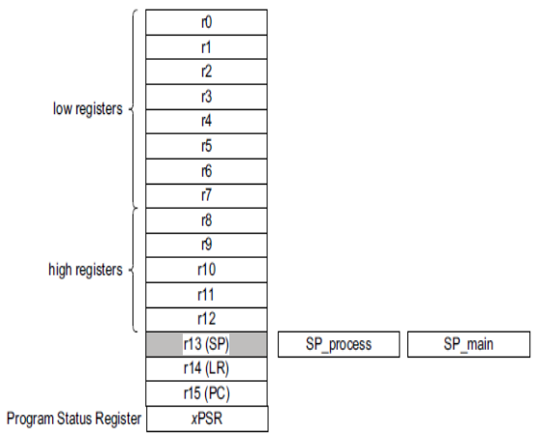

Register Set

General-purpose registers

The general-purpose registers r0-r12 have no special architecturally-defined uses. Most
instructions that can specify a general-purpose register can specify r0-r12.

Low registers Registers r0-r7 are accessible by all instructions that specify a
general-purpose register.

High registers Registers r8-r12 are accessible by all 32-bit instructions that specify a general-purpose register.
Registers r8-r12 are not accessible by all 16-bit instructions.

Stack pointer Register r13 is used as the Stack Pointer (SP). Because the SP
ignores writes to bits [1:0], it is autoaligned to a word, four-byte
boundary.
Handler mode always uses SP_main, but you can configure
Thread mode to use either SP_main or SP_process.

Link register Register r14 is the subroutine Link Register (LR).
The LR receives the return address from PC when a Branch and
Link (BL) or Branch and Link with Exchange (BLX) instruction is
executed.
The LR is also used for exception return.
At all other times, you can treat r14 as a general-purpose register.
Program counter Register r15 is the Program Counter (PC).
Bit [0] is always 0, so instructions are always aligned to word or
halfword boundaries.

Special-purpose Program Status Registers (xPSR)
Processor status at the system level breaks down into three categories:
• Application PSR -The Application PSR (APSR) contains the condition code flags. Before entering an exception, the processor saves the condition code flags on the stack.
• Interrupt PSR-The Interrupt PSR (IPSR) contains the Interrupt Service Routine (ISR) number of the
current exception activation.
• Execution PSR-The Execution PSR (EPSR) contains two overlapping fields:
- The Interruptible-Continuable Instruction (ICI) field for interrupted load multiple
and store multiple instructions
2) The execution state field for the If-Then (IT) instruction, and the Thumb state bit
(T-bit).
They can be accessed as individual registers, a combination of any two from three, or a
combination of all three using the Move to Register from Status (MRS) and MSR
instructions.

Data types
The processor supports the following data types:
• 32-bit words
• 16-bit halfwords
• 8-bit bytes.

Pin Description:

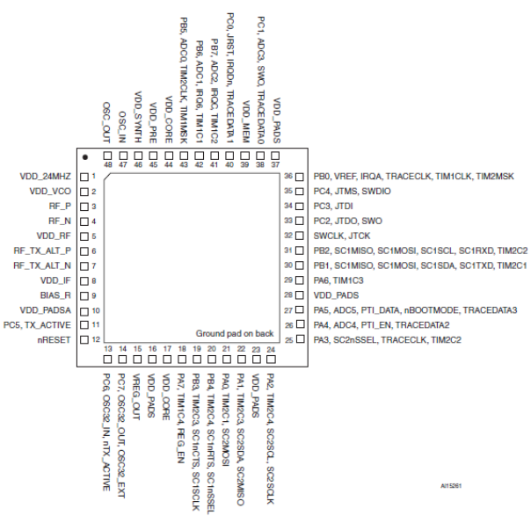

48-pin VFQFPN pinout

1 VDD_24MHZ - Power- 1x.8V high-frequency oscillator supply

2 VDD_VCO - Power- 1.8V VCO supply

3 RF_P - I/O - Differential (with RF_N) receiver input/transmitter output

4 RF_N - I/O - Differential (with RF_P) receiver input/transmitter output

5 VDD_RF - Power - 1.8V RF supply (LNA and PA)

6 RF_TX_ALT_P - O - Differential (with
RF_TX_ALT_N) transmitter output (optional)

7 RF_TX_ALT_N - O - Differential (with RF_TX_ALT_P) transmitter output (optional)

8 VDD_IF - Power - 1.8V IF supply (mixers and filters)

9 BIAS_R I - Bias - setting resistor
10 VDD_PADSA – Power - Analog pad supply (1.8V)

11
- PC5 - I/O - Digital I/O

- TX_ACTIVE - O - Logic-level control for external Rx/Tx switch. The STM32W108baseband controls TX_ACTIVE and drives it high (VDD_PADS)when in Tx mode.Select alternate output function with GPIOC_CRH[7:4]

12 nRESET - I - Active low chip reset (internal pull-up)

13
- PC6 - I/O - Digital I/O
- OSC32_IN - I/O
  - z crystal oscillator
Select analog function with GPIOC_CRH[11:8]
- nTX_ACTIVE - O
Inverted TX_ACTIVE signal (see PC5)
Select alternate output function with GPIOC_CRH[11:8]

14
- PC7 -I/O - Digital I/O
- OSC32_OUT -I/O
32.768 kHz crystal oscillator.
Select analog function with GPIOC_CRH[15:12]
- OSC32_EXT -I - Digital 32 kHz clock input source

15 VREG_OUT -Power - Regulator output (1.8 V while awake, 0 V during deep sleep)

16 VDD_PADS -Power - Pads supply (2.1-3.6 V)

17 VDD_CORE -Power - 1.25 V digital core supply decoupling

18
- PA7 - I/O-
High current Digital I/O. Disable REG_EN with GPIO_DBGCR[4]
- TIM1_CH4
  - O-
Timer 1 Channel 4 output
Enable timer output with TIM1_CCER
Select alternate output function with GPIOA_CRH[15:12]
Disable REG_EN with GPIO_DBGCR[4]

  - I -
Timer 1 Channel 4 input. (Cannot be remapped.)
- REG_EN -O -External regulator open drain output. (Enabled after reset.)

19
- PB3 I/O Digital I/O
- TIM2_CH3(see Pin 22)
- O
Timer 2 channel 3 output
Enable remap with TIM2_OR[6]
Enable timer output in TIM2_CCER
Select alternate output function with GPIOB_CRL[15:12]
- I
Timer 2 channel 3 input. Enable remap with TIM2_OR[6].
- UART_CTS I
UART CTS handshake of Serial Controller 1
Enable with SC1_UARTCR[5]
Select UART with SC1_CR
- SC1SCLK
- O
SPI master clock of Serial Controller 1
Either disable timer output in TIM2_CCER or disable remap with TIM2_OR[6]
Enable master with SC1_SPICR[4]
Select SPI with SC1_CR
Select alternate output function with GPIOB_CRL[15:12]
- I
SPI slave clock of Serial Controller 1
Enable slave with SC1_SPICR[4]
Select SPI with SC1_CR

20
- PB4 I/O Digital I/O
- TIM2_CH4 (see also Pin 24)
- O
Timer 2 channel 4 output
Enable remap with TIM2_OR[7]
Enable timer output in TIM2_CCER
Select alternate output function with GPIOB_CRH[3:0]
- I
Timer 2 channel 4 input. Enable remap with TIM2_OR[7].
- UART_RTS O
UART RTS handshake of Serial Controller 1
Either disable timer output in TIM2_CCER or disable remap with
TIM2_OR[7]
Enable with SC1_UARTCR[5]
Select UART with SC1_CR
Select alternate output function with GPIOB_CRH[3:0]
- SC1nSSEL I
SPI slave select of Serial Controller 1
Enable slave with SC1_SPICR[4]
Select SPI with SC1_CR

21
- PA0 I/O Digital I/O
- TIM2_CH1 (see also Pin 30)
  - O
Timer 2 channel 1 output
Disable remap with TIM2_OR[4]
Enable timer output in TIM2_CCER
Select alternate output function with GPIOA_CRL[3:0]
  - I
Timer 2 channel 1 input. Disable remap with TIM2_OR[4].
- SC2MOSI
  - O
SPI master data out of Serial Controller 2
Either disable timer output in TIM2_CCER or enable remap with
TIM2_OR[4]
Enable master with SC2_SPICR[4]
Select SPI with SC2_CR
Select alternate output function with GPIOA_CRL[3:0]
  - I
SPI slave data in of Serial Controller 2
Enable slave with SC2_SPICR[4]
Select SPI with SC2_CR

22
- PA1 I/O Digital I/O
- TIM2_CH3 (see also Pin 19)
  - O
Timer 2 channel 3 output
Disable remap with TIM2_OR[6]
Enable timer output in TIM2_CCER
Select alternate output function with GPIOA_CRL[7:4]
I
Timer 2 channel 3 input. Disable remap with TIM2_OR[6].
- SC2SDA I/O
I2C data of Serial Controller 2
Either disable timer output in TIM2_CCER or enable remap with
TIM2_OR[6]
Select I2C with SC2_CR
Select alternate open-drain output function with GPIOA_CRL[7:4]
- SC2MISO
  - O
SPI slave data out of Serial Controller 2
Either disable timer output in TIM2_CCER or enable remap with
TIM2_OR[6]
Enable slave with SC2_SPICR[4]
Select SPI with SC2_CR
Select alternate output function with GPIOA_CRL[7:4]
  - I
SPI master data in of Serial Controller 2
Enable slave with SC2_SPICR[4]
Select SPI with SC2_CR

23 VDD_PADS Power Pads supply (2.1-3.6V)

24
PA2 I/O Digital I/O
TIM2_CH4 (see also Pin 20)
O
Timer 2 channel 4 output
Disable remap with TIM2_OR[7]
Enable timer output in TIM2_CCER
Select alternate output function with GPIOA_CRL[11:8]
I
Timer 2 channel 4 input. Disable remap with TIM2_OR[7].
SC2SCL I/O
I2C clock of Serial Controller 2
Either disable timer output in TIM2_CCER or enable remap with
TIM2_OR[7]
Select I2C with SC2_CR
Select alternate open-drain output function with GPIOA_CRL[11:8]
SC2SCLK
O
SPI master clock of Serial Controller 2
Either disable timer output in TIM2_CCER or enable remap with
TIM2_OR[7]
Enable master with SC2_SPICR[4]
Select SPI with SC2_CR
Select alternate output function with GPIOA_CRL[11:8]
I
SPI slave clock of Serial Controller 2
Enable slave with SC2_SPICR[4]
Select SPI with SC2_CR

25
PA3 I/O Digital I/O
SC2nSSEL I
SPI slave select of Serial Controller 2
Enable slave with SC2_SPICR[4]
Select SPI with SC2_CR
TRACECLK (see also Pin 36) O
Synchronous CPU trace clock
Either disable timer output in TIM2_CCER or enable remap with
TIM2_OR[5]
Enable trace interface in ARM core
Select alternate output function with GPIOA_CRL[15:12]
TIM2_CH2 (see also Pin 31)
O
Timer 2 channel 2 output
Disable remap with TIM2_OR[5]
Enable timer output in TIM2_CCER
Select alternate output function with GPIOA_CRL[15:12]
I
Timer 2 channel 2 input. Disable remap with TIM2_OR[5].

26
PA4 I/O Digital I/O
ADC4 Analog
ADC Input 4. Select analog function with GPIOA_CRH[3:0].
PTI_EN O
Frame signal of Packet Trace Interface (PTI).
Disable trace interface in ARM core.
Select alternate output function with GPIOA_CRH[3:0].
TRACEDATA2 O
Synchronous CPU trace data bit 2.
Select 4-wire synchronous trace interface in ARM core.
Enable trace interface in ARM core.
Select alternate output function with GPIOA_CRH[3:0].

27
PA5 I/O Digital I/O
ADC5 Analog
ADC Input 5. Select analog function with GPIOA_CRH[7:4].
PTI_DATA O
Data signal of Packet Trace Interface (PTI).
Disable trace interface in ARM core.
Select alternate output function with GPIOA_CRH[7:4].
nBOOTMODE I
Embedded serial bootloader activation out of reset.
Signal is active during and immediately after a reset on NRST
TRACEDATA3 O
Synchronous CPU trace data bit 3.
Select 4-wire synchronous trace interface in ARM core.
Enable trace interface in ARM core.
Select alternate output function with GPIOA_CRH[7:4]

28 VDD_PADS Power Pads supply (2.1-3.6 V)
29
PA6 I/O
High current Digital I/O
TIM1_CH3
O
Timer 1 channel 3 output
Enable timer output in TIM1_CCER
Select alternate output function with GPIOA_CRH[11:8]
I
Timer 1 channel 3 input (Cannot be remapped.)

30
PB1 I/O Digital I/O
SC1MISO O
SPI slave data out of Serial Controller 1
Either disable timer output in TIM2_CCER or disable remap with
TIM2_OR[4]
Select SPI with SC1_CR
Select slave with SC1_SPICR
Select alternate output function with GPIOB_CRL[7:4]
SC1MOSI O
SPI master data out of Serial Controller 1
Either disable timer output in TIM2_CCER or disable remap with
TIM2_OR[4]
Select SPI with SC1_CR
Select master with SC1_SPICR
Select alternate output function with GPIOB_CRL[7:4]
SC1SDA I/O
I2C data of Serial Controller 1
Either disable timer output in TIM2_CCER,
or disable remap with TIM2_OR[4]
Select I2C with SC1_CR
Select alternate open-drain output function with GPIOB_CRL[7:4]
SC1TXD O
UART transmit data of Serial Controller 1
Either disable timer output in TIM2_CCER or disable remap with
TIM2_OR[4]
Select UART with SC1_CR
Select alternate output function with GPIOB_CRL[7:4]
TIM2_CH1 (see also Pin 21)
O
Timer 2 channel 1 output
Enable remap with TIM2_OR[4]
Enable timer output in TIM2_CCER
Select alternate output function with GPIOA_CRL[7:4]
I
Timer 2 channel 1 input. Disable remap with TIM2_OR[4].

31
PB2 I/O Digital I/O
SC1MISO I
SPI master data in of Serial Controller 1
Select SPI with SC1_CR
Select master with SC1_SPICR
SC1MOSI I
SPI slave data in of Serial Controller 1
Select SPI with SC1_CR
Select slave with SC1_SPICR
SC1SCL I/O
I2C clock of Serial Controller 1
Either disable timer output in TIM2_CCER,
or disable remap with TIM2_OR[5]
Select I2C with SC1_CR
Select alternate open-drain output function with GPIOB_CRL[11:8]
SC1RXD I
UART receive data of Serial Controller 1
Select UART with SC1_CR
TIM2_CH2 (see also Pin 25)
O
Timer 2 channel 2 output
Enable remap with TIM2_OR[5]
Enable timer output in TIM2_CCER
Select alternate output function with GPIOB_CRL[11:8]
I
Timer 2 channel 2 input. Enable remap with TIM2_OR[5].

32
SWCLK I/O
Serial Wire clock input/output with debugger
Selected when in Serial Wire mode (see JTMS description, Pin 35)
JTCK I
JTAG clock input from debugger
Selected when in JTAG mode (default mode, see JTMS description,
Pin 35)
Internal pull-down is enabled

33
PC2 I/O
Digital I/O
Enable with GPIO_DBGCR[5]
JTDO O
JTAG data out to debugger
Selected when in JTAG mode (default mode, see JTMS description,
Pin 35)
SWO O
Serial Wire Output asynchronous trace output to debugger
Select asynchronous trace interface in ARM core
Enable trace interface in ARM core
Select alternate output function with GPIOC_CRL[11:8]
Enable Serial Wire mode (see JTMS description, Pin 35)
Internal pull-up is enabled
34
PC3 I/O
Digital I/O
Either Enable with GPIO_DBGCR[5],
or enable Serial Wire mode (see JTMS description)
JTDI I
JTAG data in from debugger
Selected when in JTAG mode (default mode, see JTMS description,
Pin 35)
Internal pull-up is enabled
35

PC4 I/O
Digital I/O
Enable with GPIO_DBGCR[5]
JTMS I
JTAG mode select from debugger
Selected when in JTAG mode (default mode)
JTAG mode is enabled after power-up or by forcing NRST low
Select Serial Wire mode using the ARM-defined protocol through a
debugger
Internal pull-up is enabled
SWDIO I/O
Serial Wire bidirectional data to/from debugger
Enable Serial Wire mode (see JTMS description)
Select Serial Wire mode using the ARM-defined protocol through a
debugger
Internal pull-up is enabled

36
PB0 I/O
Digital I/O
VREF Analog O
ADC reference output.
Enable analog function with GPIOB_CRL[3:0].
VREF Analog I
ADC reference input.
Enable analog function with GPIOB_CRL[3:0].
Enable reference output with an ST system function.
IRQA I
External interrupt source A.
TRACECLK (see also Pin 25) O
Synchronous CPU trace clock.
Enable trace interface in ARM core.
Select alternate output function with GPIOB_CRL[3:0].
TIM1CLK I
Timer 1 external clock input.
TIM2MSK I
Timer 2 external clock mask input.

37 VDD_PADS Power Pads supply (2.1 to 3.6 V).

38
PC1 I/O
Digital I/O
ADC3 Analog
ADC Input 3
Enable analog function with GPIOC_CRL[7:4]
SWO (see also Pin 33) O
Serial Wire Output asynchronous trace output to debugger
Select asynchronous trace interface in ARM core
Enable trace interface in ARM core
Select alternate output function with GPIOC_CRL[7:4]
TRACEDATA0 O
Synchronous CPU trace data bit 0
Select 1-, 2- or 4-wire synchronous trace interface in ARM core
Enable trace interface in ARM core
Select alternate output function with GPIOC_CRL[7:4]

39 VDD_MEM Power 1.8 V supply (Flash, RAM)

40
PC0 I/O
High current
Digital I/O
Either enable with GPIO_DBGCR[5],
or enable Serial Wire mode (see JTMS description, Pin 35) and
disable TRACEDATA1
JRST I
JTAG reset input from debugger
Selected when in JTAG mode (default mode, see JTMS description)
and TRACEDATA1 is disabled
Internal pull-up is enabled
IRQD I
Default external interrupt source D
TRACEDATA1 O
Synchronous CPU trace data bit 1
Select 2- or 4-wire synchronous trace interface in ARM core
Enable trace interface in ARM core
Select alternate output function with GPIOC_CRL[3:0]

41
PB7 I/O
High current Digital I/O
ADC2 Analog
ADC Input 2
Enable analog function with GPIOB_CRH[15:12]
IRQC (1) I Default external interrupt source C
TIM1_CH2
O
Timer 1 channel 2 output
Enable timer output in TIM1_CCER
Select alternate output function with GPIOB_CRH[15:12]
I
Timer 1 channel 2 input (Cannot be remapped)

42
PB6 I/O
High current Digital I/O
ADC1 Analog
ADC Input 1
Enable analog function with GPIOB_CRH[11:8]
IRQB I
External interrupt source B
TIM1_CH1
O
Timer 1 channel 1 output
Enable timer output in TIM1_CCER
Select alternate output function with GPIOB_CRH[11:8]
I
Timer 1 channel 1 input (Cannot be remapped)

43
PB5 I/O
Digital I/O
ADC0 Analog
ADC Input 0
Enable analog function with GPIOB_CRH[7:4]
TIM2CLK I
Timer 2 external clock input
TIM1MSK I
Timer 2 external clock mask input

44 VDD_CORE Power 1.25 V digital core supply decoupling

45 VDD_PRE Power 1.8 V prescaler supply

46 VDD_SYNTH Power 1.8 V synthesizer supply

47 OSC_IN I/O 24 MHz HSE OSC or left open when using external clock input on OSC_OUT

48 OSC_OUT I/O 24 MHz HSE OSC or external clock input

49 GND Ground Ground supply pad in the bottom center of the package.

Embedded memory:

Memory organization and memory map

The bytes are coded in the memory in Little Endian format. The lowest numbered byte in a
word is considered the word’s least significant byte and the highest numbered byte the most
significant.

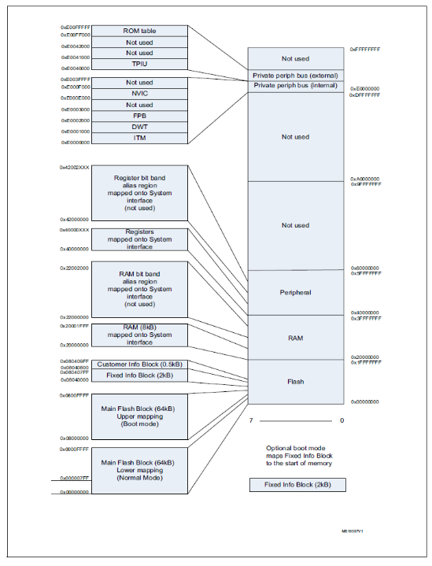

For detailed mapping of peripheral registers, please refer to the relevant section.
All the memory areas that are not allocated to on-chip memories and peripherals are
considered “Reserved”).

Flash memory

The STM32W108 provides a total of 66.5 Kbytes of Flash memory in three separate blocks:
• Main Flash Block (MFB)
• Fixed Information Block (FIB)
• Customer Information Block (CIB)

The MFB is divided into 641024-byte pages. The CIB is a single 512-byte page. The FIB is a
single 2048-byte page. The smallest erasable unit is one page and the smallest writable unit
is an aligned 16-bit half-word. The Flash is guaranteed to have 10k write/erase cycles. The
Flash cell has been qualified for a data retention time of >100 years at room temperature.

Random-access memory

The STM32W108 has 8 Kbytes of static RAM on-chip. The start of RAM is mapped to
address 0x20000000. Although the ARM® Cortex-M3 allows bit band accesses to this
address region, the standard MPU configuration does not permit use of the bit-band feature.

The RAM is physically connected to the AHB System bus and is therefore accessible to
both the ARM® Cortex-M3 microprocessor and the debugger. The RAM can be accessed
for both instruction and data fetches as bytes, half words, or words. The standard MPU
configuration does not permit execution from the RAM, but for special purposes, such as
programming the main Flash block, the MPU may be disabled. To the bus, the RAM
appears as 32-bit wide memory and in most situations has zero wait state read or write
access. In the higher CPU clock mode the RAM requires two wait states. This is handled by
hardware transparent to the user application with no configuration required.

Memory controller registers

RAM is divided into 32 byte pages. Each page has a register bit that, when set, protects it
from being written in user mode. The protection registers (MEM_PROT) are arranged in the
register map as a 256-bit vector. Bit 0 of this vector protects page 0 which begins at location
0x2000 0000 and ends at 0x2000 001F. Bit 255 of this vector protects the top page which
starts at 0x20001FE0 and ends at 0x2000 1FFF.

Memory protection unit

The STM32W108 includes the ARM® Cortex-M3 Memory Protection Unit, or MPU. The
MPU controls access rights and characteristics of up to eight address regions, each of
which may be divided into eight equal sub-regions.

ST software configures the MPU in a standard configuration and application software should
not modify it. The configuration is designed for optimal detection of illegal instruction or data
accesses. If an illegal access is attempted, the MPU captures information about the access
type, the address being accessed, and the location of the offending software. This simplifies
software debugging and increases the reliability of deployed devices. As a consequence of
this MPU configuration, accessing RAM and register bit-band address alias regions is not
permitted, and generates a bus fault if attempted.

Radio frequency module:

The radio module consists of an analog front end and digital baseband.

Receive (Rx) path
The Rx path uses a low-IF, super-heterodyne receiver that rejects the image frequency
using complex mixing and polyphase filtering. In the analog domain, the input RF signal
from the antenna is first amplified and mixed down to a 4 MHz IF frequency.

Transmit (Tx) path
The STM32W108 Tx path produces an O-QPSK-modulated signal using the analog front
end and digital baseband. The area- and power-efficient Tx architecture uses a two-point
modulation scheme to modulate the RF signal generated by the synthesizer. The modulated
RF signal is fed to the integrated PA and then out of the STM32W108.

System modules:

System modules encompass power, resets, clocks, system timers, power management, and
encryption.
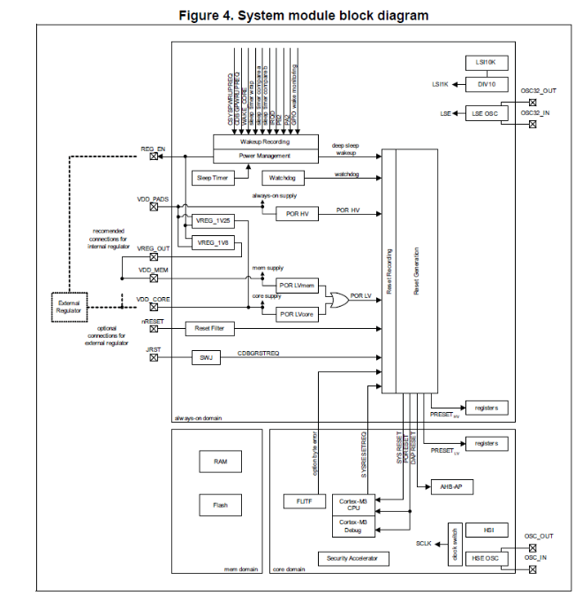

Clocks

The STM32W108 integrates four oscillators:
• High frequency RC oscillator (HSI)
• 24 MHz crystal oscillator (HSE)
• 10 kHz LSI RC oscillator (LSI10K)
• 32.768 kHz crystal oscillator (LSE)

The LSI1K clock is generated from the 10 kHz LSI RC oscillator (LSI10K). The default value
is a divide by 10 for a nominal 1 kHz output clock.

GPIO ports:

The 24 GPIO pins are grouped into three ports: PA, PB, and PC. Individual GPIOs within a
port are numbered 0 to 7 according to their bit positions within the GPIO registers.
Because GPIO port registers' functions are identical, the notation x is used here to refer to
A, B, or C. For example, GPIOx_IDR refers to the registers GPIOA_IDR, GPIOB_IDR, and
GPIOC_IDR.

Each of the three GPIO ports has the following registers whose low-order eight bits
correspond to the port's eight GPIO pins:
• GPIOx_IDR (input data register) returns the pin level (unless in analog mode).
• GPIOx_ODR (output data register) controls the output level in normal output mode.
• GPIOx_BRR (clear output data register) clears bits in GPIOx_ODR.
• GPIOx_BSR (set output data register) sets bits in GPIOx_ODR.
• PWR_WAKEPxR (wake monitor register) specifies the pins that can wake the STM32W108.

Interrupts:

1) The interrupt system of the STM32W108 is composed of two parts:
• A standard ARM® Cortex-M3 Nested Vectored Interrupt Controller (NVIC) that
provides top level interrupts
• An Event Manager (EM) that provides second level interrupts.

Vectored Interrupt controller

---- 0 Stack top is loaded from first entry of vector table on reset.
Reset 1 Invoked on power up and warm reset. On first instruction, drops to
lowest priority (Thread mode). Asynchronous.
NMI 2 Cannot be stopped or preempted by any exception but reset.
Asynchronous.
Hard Fault 3 All classes of fault, when the fault cannot activate because of priority
or the Configurable Fault handler has been disabled. Synchronous
Memory Fault 4 MPU mismatch, including access violation and no match.
Synchronous.
Bus Fault 5 Pre-fetch, memory access, and other address/memory-related faults.
Synchronous when precise and asynchronous when imprecise.
Usage Fault 6 Usage fault, such as 'undefined instruction executed' or 'illegal state
transition attempt'. Synchronous.
--- 7-10 Reserved, must be kept at reset value
SVCall 11 System service call with SVC instruction. Synchronous.
Debug Monitor 12 Debug monitor, when not halting. Synchronous, but only active when
enabled. It does not activate if lower priority than the current
activation.
--- 13 Reserved, must be kept at reset value
PendSV 14 Pendable request for system service. Asynchronous and only pended
by software.
SysTick 15 System tick timer has fired. Asynchronous.
Timer 1 16 Timer 1 peripheral interrupt.
Timer 2 17 Timer 2 peripheral interrupt.
Management 18 Management peripheral interrupt.
Baseband 19 Baseband peripheral interrupt.
Sleep Timer 20 Sleep Timer peripheral interrupt.
Serial Controller1 21 Serial Controller 1 peripheral interrupt.
Serial Controller2 22 Serial Controller 2 peripheral interrupt.
Security 23 Security peripheral interrupt.
MAC Timer 24 MAC Timer peripheral interrupt.
MAC Transmit 25 MAC Transmit peripheral interrupt.
MAC R 26 MAC Receive peripheral interrupt.
ADC 27 ADC peripheral interrupt.
IRQA 28 IRQA peripheral interrupt.
IRQB 29 IRQB peripheral interrupt.
IRQC 30 IRQC peripheral interrupt.
IRQD 31 IRQD peripheral interrupt.
Debug 32 Debug peripheral interrupt.

2) Several kinds of timer events can generate a timer interrupt, and each has a status flag in
the TIMx_SR register to identify the reason(s) for the interrupt:
• TIE - set by a rising edge on an external trigger, either edge in gated mode
• CCyIF - set by a channel y input capture or output compare event
• UIF - set by an update event

Clear bits in TIMx_SR by writing a 1 to their bit position. When a channel is in capture mode,
reading the TIMx_CCRy register will also clear the CCyIF bit.

The TIMx_IER register controls whether or not the TIMx_SR bits actually request an ARM®
Cortex-M3 timer interrupt. Only the events whose bits are set to 1 in TIMx_IER can do so.

Time-base unit

The main block of the general purpose timer is a 16-bit counter with its related auto-reload
register. The counter can count up, down, or alternate up and down. The counter clock can
be divided by a prescaler.
The counter, the auto-reload register, and the prescaler register can be written to or read by
software. This is true even when the counter is running.
The time-base unit includes:
• Counter register (TIMx_CNT)
• Prescaler register (TIMx_PSC)
• Auto-reload register (TIMx_ARR)

Counter modes:

Up-counting mode
In up-counting mode, the counter counts from 0 to the auto-reload value (contents of the
TIMx_ARR register), then restarts from 0 and generates a counter overflow event.
An update event can be generated at each counter overflow, by setting the UG bit in the
TIMx_EGR register, or by using the slave mode controller.

Down-counting mode
In down-counting mode, the counter counts from the auto-reload value (contents of the
TIMx_ARR register) down to 0, then restarts from the auto-reload value and generates a
counter underflow event.
An update event can be generated at each counter underflow, by setting the UG bit in the
TIMx_EGR register, or by using the slave mode controller). Software can disable the update
event by setting the UDIS bit in the TIMx_CR1 register, to avoid updating the shadow
registers while writing new values in the buffer registers. No update event occurs until the
UDIS bit is written to 0. However, the counter restarts from the current auto-reload value,
whereas the prescalar's counter restarts from 0, but the prescale rate doesn't change.

Center-aligned mode (up/down counting)
In center-aligned mode, the counter counts from 0 to the auto-reload value (contents of the
TIMx_ARR register) - 1 and generates a counter overflow event, then counts from the
autoreload value down to 1 and generates a counter underflow event. Then it restarts
counting from 0.

some examples of the counter
behavior for different clock frequencies when TIMx_ARR = 0x36 =>

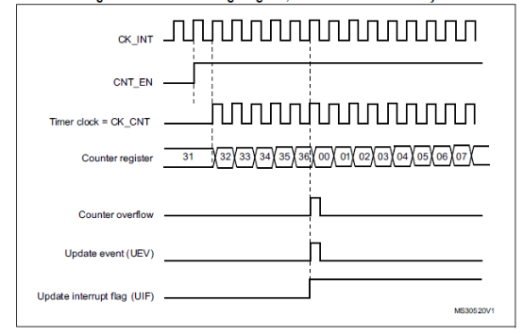
Internal Clock Divided by 1

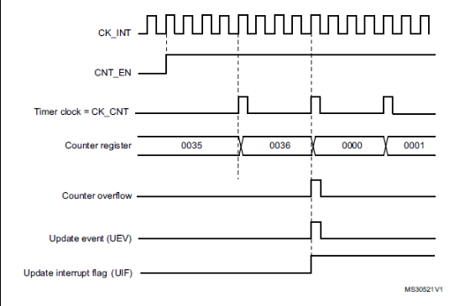
Internal Clock Divided by 4

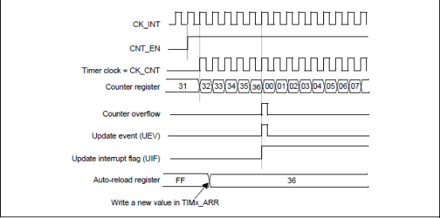
No Buffer

General-purpose timers:

Each of the STM32W108's two general-purpose timers consists of a 16-bit auto-reload
counter driven by a programmable prescaler. They may be used for a variety of purposes,
including measuring the pulse lengths of input signals (input capture) or generating output
waveforms (output compare and PWM).
• 16-bit up, down, or up/down auto-reload counter.
• Programmable prescaler to divide the counter clock by any power of two from 1
through 32768.
• 4 independent channels for:
– Input capture
– Output compare
• PWM generation (edge- and center-aligned mode)
• One-pulse mode output
• Synchronization circuit to control the timer with external signals and to interconnect the
timers.
• Flexible clock source selection:
– Peripheral clock (PCLK at 6 or 12 MHz)
– 32 kHz HSE OSC (if available)
– 1 kHz clock

Analog-to-digital converter:

The STM32W108 analog-to-digital converter (ADC) is a first-order sigma-delta converter
with the following features:
• Resolution of up to 12 bits
• Sample times as fast as 5.33 μs (188 kHz)
• Differential and single-ended conversions from six external and four internal sources
• Two voltage ranges (differential): -VREF to +VREF, and –VDD_PADS to +VDD_PADS
• Choice of internal or external VREF: internal VREF may be output
• Digital offset and gain correction
• Dedicated DMA channel with one-shot and continuous operating modes

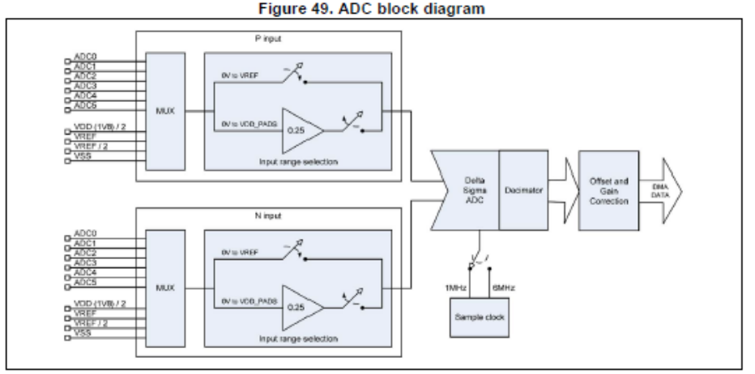
Conclusion:

The STM32w108 (involving ARM Cortex-M3) was a big step for the STMicroelectronics as it overcame various shortcomings of its predecessors and at the same time had various new additions to its features.
With added support of Analog-to-digital converter and 3-stage pipeline, it laid the foundations for its successors of STM architecture for improvements.

